9/1/2019
A project to support St Giles Hospital
An initiative by the Human rights Alumni of USP
In partnership with Oceania Pride and Rewa Community Care
St Giles Hospital Community Project 2019

Table of figures

Figure 1: Women’s ward sink 1
Figure 2: Men’s ward sink 1
Figure 3: State of the rubber tiles throughout the wards 1
Figure 4: Table in women’s ward used for dinning 1
Figure 5: Other structures around the facility 2
Figure 6: Plumbing and drainage 2

Contents
Organizational Background 3
Problem Statement 4
Project Justification 5
Project Goals 6
Project Activities 7
Phase one will include the following strategies 7
Phase two will include the following strategies: 7
Phase 3 will include the following strategies: 7
Project Results 8
Short-Term (Completion - 1 month) 8
Medium-Term (3 months) 8
Long-Term (6 months) 8
Budget 0
Conclusion 1
Annex 2

Organizational Background

The Human Rights Alumni of USP is a discipline alumni at Laucala Bay campus. We are an alumni created by the graduates of the Governance, Leadership and Human Rights program under the School of Governance, Development and International Affairs, Faculty of Business and Economics. As one of the objectives of an alumni we are required to do at least one community project each year.

Our goal as an alumni is to accomplish the following:
- Create a more robust advocacy culture within student bodies
- Conduct research on various social and issues
- Encourage community work among students
- Increase networking among alumni members and other bodies

We hope to further our progress to reaching our community engagement goals through the project outlined in this proposal.

Problem Statement
Mental health services continues to be stigmatized in Fiji. This is especially true for the St Giles Hospital which is seldom seen as a place of rehabilitation. Healthcare remains one of the development challenges in Fiji and over the year’s St Giles hospital has not received the attention it deserves towards infrastructure development.

“Infrastructure is a key pillar supporting the fundamental aim of promoting improved standards of care and wellbeing for all patients. Wards and patient areas should have space, light and good views wherever possible, to promote a patient-friendly and healing environment” (Luxon, 2015).

The building and the furniture at the facility is run down and it needs an uplift.

We would like to help make the in-patients facilities better by implementing this project in 3 phases:
- Clean up of buildings and assessment of the property for renovations
- Repair or acquirement of new furniture and other facilities
- Repainting
- Any other minor renovations necessary

Project Justification

The pictures from our initial assessment visit to the premises have been annexed to this document. The pictures are a testimony of how deteriorated the facility is and needs maintenance.

The dining area where patients eat is in a very poor state with the tables almost falling to pieces.

The benches the patients sit on are hard and shaky.

The sink area is rotting away and needs stainless steel work so that it can be longer lasting.

These areas may not be of OHS standards and the patients deserve better facilities.

They have no entertainment since the TV screen is broken.

Project Goals
Completion of this project will further our overarching objectives, including:

- Clean up of buildings and assessment of the property for renovations
- Repair or acquirement of new furniture and other facilities
- Repainting
- Any other minor renovations necessary

Project Activities

Phase one will include the following strategies:

Fundraising for supplies and volunteer lunch
Water blasting of the cement structures
Cleaning the wooden structures with soap and water using manpower (wood structure)
Access for other work that may be required
Estimation of cost and materials needed for repainting and other minor maintenance work needed by a carpenter

Phase two will include the following strategies:

Fundraising to cover project cost
Repainting of the female ward, male ward and the common areas
Assessment for repair of existing structures and furniture’s
Estimation of cost and materials needed for phase 3

Phase 3 will include the following strategies:

Carry out maintenance work

Project Results
The impact of the St Giles Hospital community project will be felt in the short, medium, and long term. The following are the project results which will be realized upon completion:

Short-Term (Completion - 1 month)

Thorough clean-up of the women’s and men’s wards and common areas frequented by the in-patients

Medium-Term (3 months)

Painting of the wards
New sink benches for female and male dining area
Tables and chairs for the dining area

Long-Term (6 months)

Grills in the kitchen windows

Replacing the rubber tiles

Plumbing

Other minor repairs

Budget for phase one
 | Budget for St. Giles Clean-up Campaign
 | 28th September 2019
 | Description | $ | $
 | Cleaning Equipment
 | -Hire of Water blaster (2x) | 700.00
 | -Hire of ladder (2x) | 500.00
 | -Purchase/ hire of Brush (5x) | 175.00
 | -Purchase/ hire of Mops (3x) | 60.00
 |  |  | 1,435.00
 | Cleaning Items
 | -Soap Powder | 50.00
 | -Janola | 50.00
 | -Racks | 50.00
 | -Multi-purpose cleaner | 50.00
 | -Gloves | 50.00
 |  |  | 250.00
 | Catering for Volunteers
 | -Food for Volunteers | 650.00
 | -Drinking Water | 250.00
 | -Snacks | 100.00
 | -Fruits | 100.00
 | -Icekey box hire | 50.00
 | -T-Shirts for Volunteers | 1,200.00
 |  |  | 2,350.00
 | Transportation |  | 50.00
 | TOTAL BUDGET |  | 4,085.00
 | Note:
 | *Hiring of equipment’s are for day of clean-up
 | *Requesting to hire 2 water blaster & 2 ladder to streamline workload
 | *Estimate volunteers 80 people
 | *80 T-Shirts for volunteers at Approx$15.00 per shirt
 | *Transporting cleaning equipment, items and other miscellaneous runs
 | All cost are estimation

Conclusion

We believe that St Giles hospital is a worthy cause that will do a great deal of good to provide an enabling environment for the patients admitted at the hospital. We're excited to partner with others to make this project a reality, leading to substantial benefits in the short, medium, and long term for the patients admitted into the psychiatric hospital.

Annex

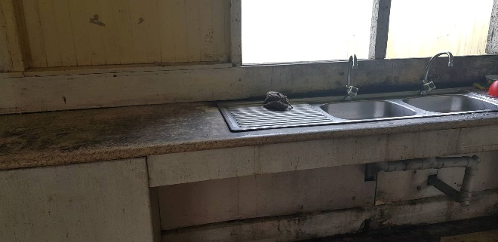
Figure 1: Women’s ward sink

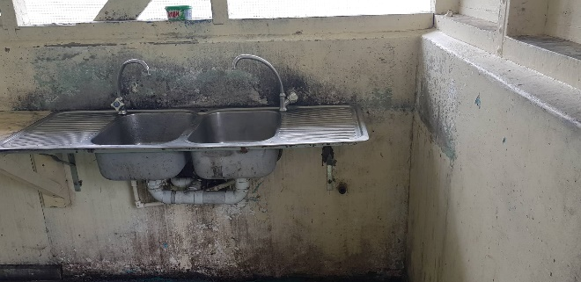
Figure 2: Men’s ward sink

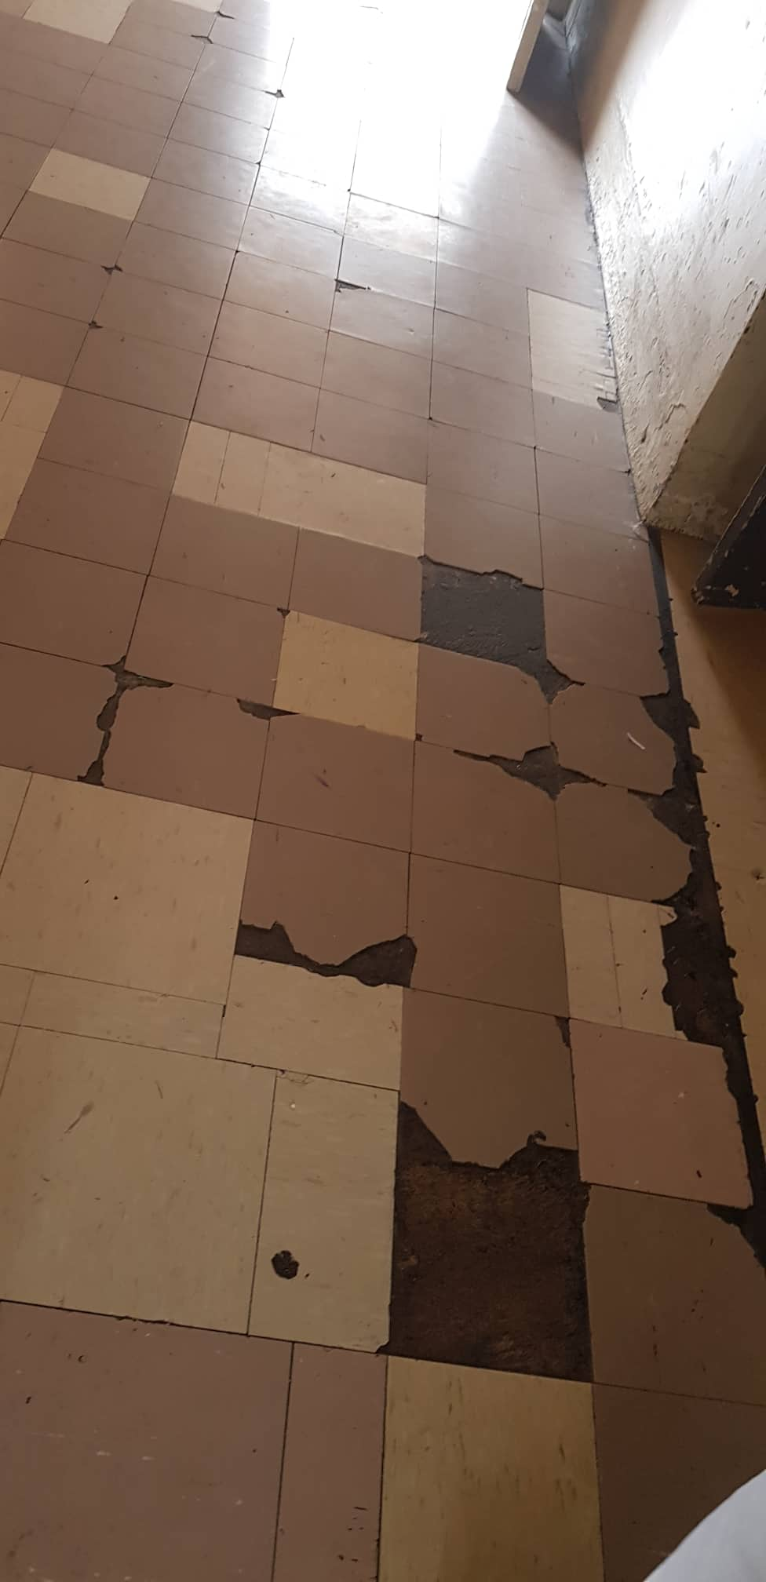
Figure 3: State of the rubber tiles throughout the wards

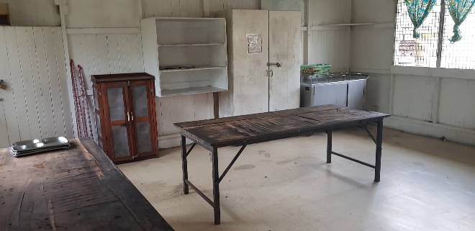
Figure 4: Table in women’s ward used for dinning

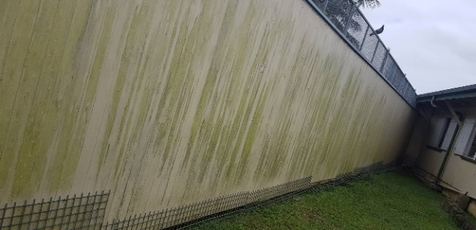

Figure 5: Other structures around the facility

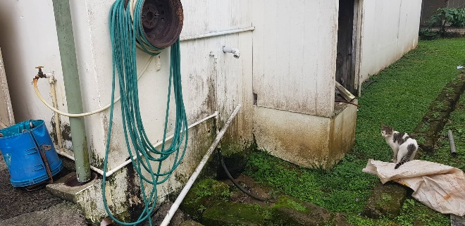
Figure 6: Plumbing and drainage

