Contractor Induction Checklist
Date:
Contractor:
Project site:
Job card number/ Contract number:
Discussion | Despcription
Barricading | The contractor is responsible to barricade the construction site with orange or green netting for any Major works that will be awarded. Cones & ‘A’ frame Signage’s is permitted for minor works only. Strictly, caution tapes will be used during immediate emergencies only.  - No materials should be lying loose on the ground and beyond the barricaded worksite | ☐
Signages | For Minor works, use of caution ‘A’ frame Signage’s is permitted.  For Major works, the site signage should have the following details:  - Company Name & Logo  - Company Contact Details  - Minimum Site Required PPE  - The Hazards Relating to the Site | ☐
PPE’s | All workers & visitors on the construction site should be fully equipped with the required safety gears, and they should wear them while on-site at all times | ☐
First Aid | - Nominated first aider(s)  - (Provide training certificates for persons mentioned above)  - A First Aid Kit to be on-site at all times  - Call the ambulance for major injuries | ☐
Permits | Working at Heights Permits  Any works carried out above 1.8 meters require working at heights permit  Hot Works Permit  Any Hot Works is carried out, such as welding, grinding, cutting, brazing etc.  Confined Space  Any works carried out in confined or enclosed spaces, such as lift shafts, tanks, etc. Assess site for risk of Asphyxiation and proper ventilation; Coordinate with USP for any underground/concealed services.  NB: Conduct the necessary site risk assessments for the works. Above mentioned works requires a permit. All Safety measures need to be implemented before the permit is issued. All copies of the permit must be emailed to the USP representative every week. The copy of the permit should be made available at the worksite. | ☐
Safety Improvement Notice ( SIN) | - First Warning – Written email warning will be issued if any breaches of OHS is identified by USP. Maximum of 48 hours to address the issue;  - If the Issue is not addressed after a specified time limit, SIN is issued, and a Stop of Works is issued;  - In accordance with the contract, all fines and penalties will apply.  For breaches of safety, all SIN records will be kept by USP procurement team for contractor performance management  Note: if the contractor is found breaching mandatory OHS compliance requirements, the OHS unit will instantly issue Safety Improvement notice (SIN) without following the steps of issuing notice. | ☐
Site attendance | An attendance register is to be kept -site where staff or visitors are to sign in and sign out. The Logbook will be checked upon audits. | ☐
Emergency Evacuation | When the fire or tsunami sirens are activated, the contractor’s staff should heed the advice from their emergency warden and move to the designated assembly areas. The emergency warden on-site will be responsible for taking the headcount for staff. | ☐
Using of USP Amenities | This will vary based on the projects awarded. The responsible USP staff for the worksite will show which site amenities to be used. | ☐
General
No Smoking policy | 1st January 2021 The University of the South Pacific was declared smoke free across all its campus. If an individual is caught smoking within USP premises, then they will be fined by the USP Security team. | ☐
Harassment /passing remarks | Encourage/advise your staff not to pass any remarks/comments to any staff or students on campus. If any report is received, the matter will be handed over to the relevant authorities. | ☐
Security Information | - Follow the road rules and be mindful of the crossing and students on campus.  - Use the Gates closest to the project site for entry and exit. Do not loiter around the campus for no reason.  - Strictly all materials and tools brought in for use on-site are not the responsibility of USP security to look after during the night or weekend. Do not place any tools under the security office or security post.  - Liaise with campus security for the use of any large construction vehicles  - All staff on-site should carry an ID card or wear company uniforms. The list is to be given to the person responsible for the project and USP Security.  - Sign in & Sign out with campus security  - For any breach of parking and speed requirements, fines will apply in accordance to the contract  - For any work being done after hours, the USP representative and security are to be advised. | ☐
COVID-19 Requirements | Contractors are to ensure they adhere to the COVID Safety requirements:  - The university will continue to support the work of the respective countries' government and their ministries in the fight against COVID 19, to safeguard its staff, students and residents.  - Kindly provide your relevant details to security, when entering & exiting USP premises should it be required. Please refrain from entering the premises should you be exhibiting fever like symptoms.  - Adhere to the advisories from your respective Government and any university protocols that may be in place. | ☐

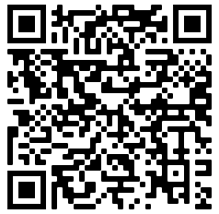 | 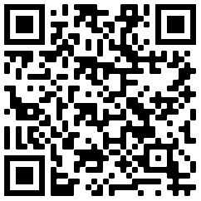 |  | 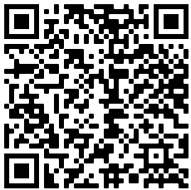
OHS Permit Template | Contact Details | OHS Webpage | Induction Video
Signed by:
Contractor:  Name:  Date: |  | USP Representative:  Name:  Date:

