    - Project Title: ________
Project No.: _________
Date: ______________
- Introduction
- Provide background and context of the project (refer space form)
- Scope of Project
- Provide scope of project outlining dimension, quantities, space usage, etc.

- Governance Structure
Example:
Sponsor (SMT)
Name:

Project Manager
Name:

Client (Facility User)
Name:

Clerk of Works
Name:

- Costing and Funding
Fill out the below table for the costing and funding details (place N/A where information is not available)
Item | Space Form Estimate | Design Cost (Estimate) | Tender Estimate/Cost (Vote Code) | Construction Estimate/Cost  (PO #)
- Objectives
  - USP Objective
- provide a brief University objective focusing on the Strategic Plan Priority areas that this project fall under
  - Client Objective
- provide a brief client objective that will be achieved for this project
  - Project Objective
- provide a brief project objective that will be achieved for this project such as getting certifications, timeline, scope and budget

- Inputs – Design Phase

  - Approved Space Form

- Outputs – Design Phase

  - Approved Design Brief
  - Concept Design and Cost Plan
  - Detailed Design, Technical Specification and Cost Plan
  - Approved ITB documents:
    - Tender drawings
    - Technical Specification
    - Contract Document
    - Technical Evaluation Criteria
    - Price Bid Template

- Inputs – Tender Phase
  - Vote code funding
  - Approved ITB documents

- Outputs – Tender Phase
  - Technical evaluation report
  - Price evaluation report

- Inputs – Construction Phase
  - Purchase Order (P.O)
  - Signed Contract
- General conditions of contract
- All contract negotiation
- Contractors PI and all risks insurance covers
- Contractor tender submission
  - Construction work program
  - Project kick-off meeting minutes (checklist)

- Outputs – Construction Phase
  - Clerk of Works weekly report
  - Practical completion report
  - Project close out report
  - Energy Fiji Limited certificate

- Timeline
- provide a project Gantt chart showing project task
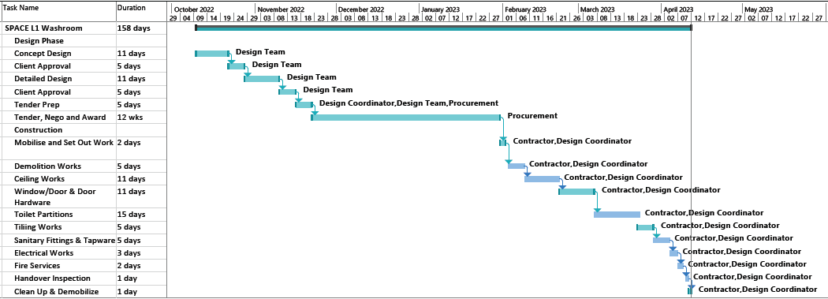
- Key Performance Indicators (KPI)
The following KPI’s needs to be monitored:
  - OHS Safety and Zero Incident on site
  - Recycling of the waste materials
- A – 20% recycled
- B – 0% recycled
- C – unsalvageable items left on site
  - Number of defects at 1 month post practical completion
- A - Proactive
- B - Satisfactory
- C – Dissatisfied
  - Client feedback survey
- A – very satisfactory
- B – average/satisfactory
- C – dissatisfied
- Reporting Requirements
- update the reporting table below based on the project requirement

Reported By | To Whom | Reporting Requirement | Format
Clerk of Works | Client, Project Sponsor and Director E & I | Weekly | Clerk of Works Weekly Report
Project Manager | Client, Project Sponsor and Director E & I | At the Practical Completion of the project | Practical Completion Report
Project Manager | Client, Project Sponsor and Director E & I | At the End of Defects Liability Period | Project Close Out Report

- Responsibilities
  - Client – the Client responsibilities are as follows:
    - Provide endorsement and sign-off on reports
  - Project Coordinator – the Project Coordinator responsibilities are as follows:
    - Making sure building users comply with the OHS site signage
    - Manage the contract and the performance of the contractor
    - Making sure compliance to approved project plan
    - Making sure the project sponsor is updated on the progress of the construction

- Risk Register
- Prepare a project risk register only to focus on the project risk from the scope, budget and timeline. OHS and safety items need to be highlighted.
- Review and approve the risk register with the client. This should be done at key project output.

Risk Description | Potential Causes of the risk | Risk Owner |  | Current internal Controls (provide details of how you currently manage the risk) |  |  | Assessment of Risk |  |  | Overall indicator
 |  |  |  |  |  |  | Likelihood (1,2,3,4,5) | Impact (1,2,3,4,5) | Score
Design
Delay in finalising the design documents | Scope – verify unseen services / covered plumbing services | - Design Manager | - Site inspection including tracing of existing services  - Consultation with maintenance team  Output  - Drawings showing existing services |  |  | 1 |  | 3 | 3
 | Poor design – resource assignment | - Design Manager | - Provide realistic timeline for the design to be completed.  Output  - Signed SOP’s for the project |  |  | 1 |  | 3 | 3
 | Quality control | - Design Manager | - Quality check on missing items such as signage for flush signage, toilet cleaning and emergency contact, push tap. etc.  Output  - Drawings showing project signage |  |  | 1 |  | 3 | 3
Tender
Delay to project timeline/delivery | Contract award timeline | - Project Coordinator  - Procurement Manager |  |  | - Comply with tender timeline including arranging for TEC and final contract award  - Calling for site pre-bid meeting  Output  - TEC meeting minutes  - Contractor site visit and attendance register |  | 3 | 4 | 12
Construction
Delay to project timeline/ delivery | Loss of time due to Injury | - Project Coordinator |  | - OHS induction and daily reminders/ refreshers during progress meeting updates and toolbox meetings.  Output  - Signed OHS Checklist, Permits (Hot works & Heights) |  |  | 2 | 5 | 10
 | Supply of Materials | - Project Coordinator |  | - Design phase materials verification at local hardware  - Pre-bid meeting to verify with the contractors  - Contract penalties to contractor (selective materials only)  - Kick –off meeting – supplier confirmation on material delivery  Output  - Design phase checklist  - Meeting minutes  - CoW weekly report |  |  | 1 | 3 | 3
Risk of injury or death | - Electrocution  - Not using trained staff  - Not using PPE  - Poor site safety  - Poor contractor works methodology | - Project Coordinator |  | - OHS induction for contractor staffs  - Provide site safety signage  - Contractor to have toolbox meeting daily  Output  - OHS Induction checklist & sign-off  - CoW weekly report  - SIN issued to the contractor |  |  | 3 | 2 | 6
Design changes during construction | Unapproved materials used for the construction and compliance not met | - Project Coordinator |  | - Design changes or selection of materials needs to be approved by the Design Team  - NTC to be issued by the contractor  Output  - Design team approvals and NTC issued to contractor |  |  | 3 | 2 | 6

Impact | Extreme (5) | Low (5) | Medium (10) | High (15) | Extreme (20) | Extreme (25) | Impact Rating from 1-5 is assigned based on following any one of the following conditions being met:  1. No lost time injury (minor cut/abrasion/first aid kit on site) – Cost impact less than 1% of project sum, and no delays  2. Lost time injury less than 5 days – Cost impact less than 5% of project sum, delay less than 5 days.  3. Lost time injury less than 1 month – Cost impact less than 10 % of project sum, delay less than 1 month  4. Lost time injury greater than 1 month or Permanent disability – Cost impact less than 15 % of project sum, delay greater than 1 month but less than contract length  5. Death – Cost impact greater than 15% of project sum, delay greater than duration of contract
 | Major (4) | Low (4) | Medium (8) | Medium (12) | High (16) | Extreme (20)
 | Moderate (3) | Low (3) | Low (6) | Medium (9) | Medium (12) | High (15)
 | Minor (2) | Low (2) | Low( 4) | Low (6) | Medium (8) | Medium (10)
 | Insignificant (1) | Low (1) | Low (2) | Low (3) | Low (4) | Low (5)
 |  | Rare (1) | Unlikely (2) | Possible (3) | Likely(4) | Almost Certain (5)
 |  | Less than 10% chance of occurrence | 10-39% chance of occurrence | 40-69% chance of occurrence | 70-79% chance of occurrence | 80% or above chance of occurrence
 |  | Likelihood Scale

Project Plan Approval

Reviewed By
Date

Approval
Date

Client Approval
Date

SMT Approval
Date

