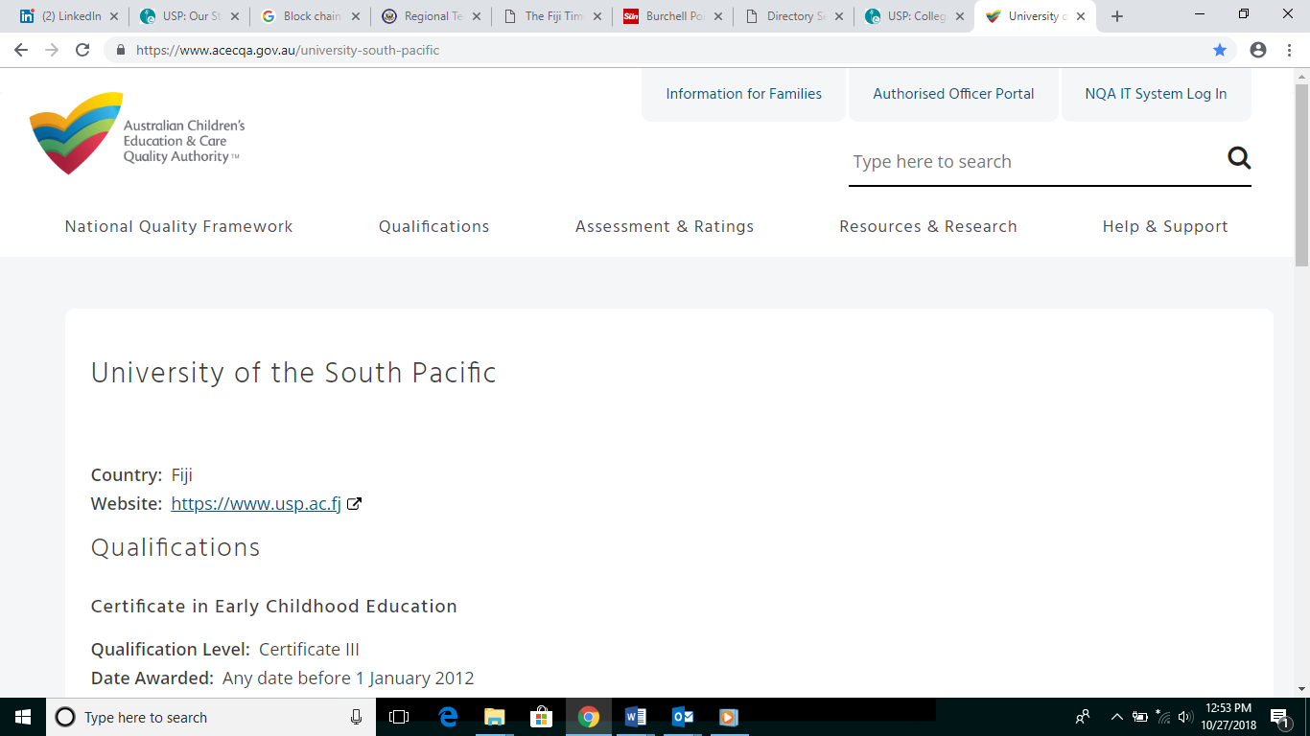



**CERTIFICATE III IN EARLY CHILDHOOD CARE AND EDUCATION**

**This qualification is internationally accredited by the Australian Children’s Education & Care Quality Authority (ACECQA) and nationally accredited on the Fiji Qualifications Framework (FQF) by the Fiji Higher Education Commission (FHEC). It is also registered on the Pacific Register of Qualifications and Standards (PRQS).**

# DESCRIPTION

This qualification prepares students with skills and knowledge required by child caregivers working with infants and toddlers to ensure that the children’s physical and emotional wellbeing is maintained and their self-sufficiency is nurtured. Students will learn to use an informed programme-planning cycle that is based on information gathered through observing children’s play and learning. It will explore legislative and policy frameworks, aspects of workplace health and safety and first aid responses to infants, children and adults. It discusses cross-cultural issues involving Pacific communities and prepares students to be proactive members of an innovative team that communicates and cooperates with persons of diverse cultures.

# CAREER OPPORTUNITIES

Job roles and titles vary across different industry sectors. Possible job titles relevant to this qualification include but not limited to:

* Assistant Pre-school Teacher
* Day Care Worker
* Child Caregivers in Hotels and Resorts
* Nanny

# LENGTH OF PROGRAMME

|  |  |
| --- | --- |
| Full Time | 1 year |
| Part Time | 1 and half years |

# ELIGIBILITY/ADMISSION REQUIREMENTS

To be admitted to this programme, a person shall have:

1. A pass in Senate recognised Form 4 / Year 10 or equivalent with English and must be 18 years and over; or
2. Met the mature student admission criteria; or
3. Three (3) years early childhood teaching experience.

# COURSE INFORMATION

This programme has a total of five (5) courses.

|  |  |  |  |  |  |
| --- | --- | --- | --- | --- | --- |
| **Course Code** | **Course Title** | **Semester** | **Delivery Mode** | **Campus** | **Fees (FJD)** |
| CEE31 | Child Development & Care | 1 & 2 | Blended | All  Campuses | $335 |
| CEE32 | Curriculum Studies | 1 & 2 | Blended | All  Campuses | $335 |
| CEE33 | Early Childhood Professional Practice | 1 & 2 | Blended | All  Campuses | $335 |
| CEE34 | Growing Up in a Pacific Family and  Community | 1 & 2 | Blended | All  Campuses | $335 |
| CEE35 | Early Childhood Care & Education Workplace Attachment | 1 & 2 | Blended | All  Campuses | $335 |

# ASSESSMENT

All courses are competency based and assessment varies with each course which may include observations, questions and answers, case studies, portfolios, work samples, assignments, written tasks, oral questioning, projects, training record books, practical demonstrations, and third party reports. Workplace based assessments are applicable to working students only.

# RECOGNITION OF PRIOR LEARNING

Recognition of Prior Learning (RPL) takes into account the knowledge and skills you have already gained through your previous education and work. This may be through formal or informal training, paid or unpaid work experience, and can earn you credits if relevant to the courses of this programme. Student may apply for RPL with $100 application fee when enrolling for the programme. Student is to pay full course fee for the courses that have been awarded with an RPL.

# CREDIT TRANSFER

Do you already have a qualification, statements of attainment or academic statements for courses completed at another recognised institution? If yes, Pacific TAFE may award credit transfers after assessing: learning outcomes, content, credit points and assessment tools used; and ascertaining their relevance and appropriateness to this qualification. This one-off absolute decision lies with Pacific TAFE. There is no cost for this arrangement.

# EXIT POINTS

You may exit from this qualification and receive a Statement of Attainment for courses you have successfully completed.

# LEARNING RESOURCES & SUPPORT SERVICES

Students are issued with learning materials and hand-outs relevant to each course. Some courses require the purchase of text books/manuals; these are available from the USP Book Centre and a copy is available from the University Library. Students will have full access to Library, Counselling Programmes, ITS Labs, email access, online learning support and Campus Life activities. Learning Support Team provides learning support via one-to-one consultation through an "open door” policy, Academic Skills Workshops and Industry Mentoring Programmes. Students can also access online learning support on “Moodle” which is USP’s online learning management system.

# USP’S OBLIGATIONS, STUDENTS’ RIGHTS

The Student Grievance Policy and Procedures apply to all students of the University. The Student Grievance Policy provides the guiding principles for resolving student grievances, and appealing decisions about grievances. The Policy is accompanied by the Student Grievance Procedures (together referred to as the ‘Student Grievance Policy and Procedures’). Students enrolled in a course will automatically become members of the USP Students’ Association.

**FOR MORE INFORMATION CONTACT:**

Customer Service Centre

Phone: 3231223/3231224/3231870

Email: pacifictafe@usp.ac.fj

Website: [www.usp.ac.fj/pacifictafe](http://www.usp.ac.fj/pacifictafe)