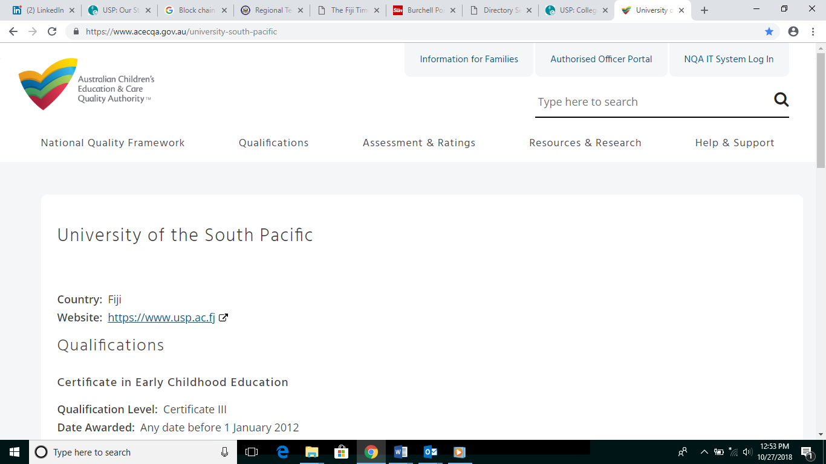



**DIPLOMA OF EARLY CHILDHOOD CARE & EDUCATION (Level 5)**

**This qualification is internationally accredited by the Australian Children’s Education & Care Quality Authority (ACECQA) and nationally accredited on the Fiji Qualifications Framework (FQF) by the Fiji Higher Education Commission (FHEC). It is also registered on the Pacific Register of Qualifications and Standards (PRQS).**

# DESCRIPTION

This qualification addresses the skills and knowledge required to provide care for children below eight years of age. It builds on professional practices of a child carer and educator through designing and implementing child-centred curriculum within the requirements of an approved framework or guideline in caring, learning, safety, health and child protection. Students will have the opportunity to demonstrate leadership and management skills by supervising a team in a simulated environment or at a selected day care or learning centre.

# CAREER OPPORTUNITIES

Job roles and titles vary across different industry sectors. Possible job titles relevant to this qualification include but not limited to:

* Pre-school Teacher
* Child Welfare Officer
* Day Care Worker
* Childcare Worker in Hotels and Resort
* Professional Nanny

# LENGTH OF PROGRAMME

|  |  |
| --- | --- |
| Full Time | 2 years |
| Part Time | 2 and half years |

# ELIGIBILITY/ADMISSION REQUIREMENTS

To be admitted to this programme, a person shall have:

1. A pass in Senate recognised Year 12 / Form 6 or equivalent with English; or
2. Complete Certificate III/IV in Early Childhood Education & Care from a recognized institution or
3. Met mature student admission criteria.

# COURSE INFORMATION

This programme has a total of 12 courses.

|  |  |  |  |  |  |
| --- | --- | --- | --- | --- | --- |
| **Course Code** | **Course Title** | **Semester** | **Delivery**  **Mode** | **Campus** | **Fees (FJD)** |
| CEE41 | Child Development and Care for Special Needs | 1 & 2 | Blended | All  Campuses | $455 |
| CEE42 | Children & Childhood | 1 & 2 | Blended | All  Campuses | $455 |
| CEE43 | Understanding and Supporting Young Children’s Behaviour | 1 &2 | Blended | All  Campuses | $455 |
| CEE44 | Young Children’s Health and Wellbeing | 1 & 2 | Blended | All  Campuses | $455 |
| CEE45 | Practices and Skills of an EarlyChildhood Care & Education  Professional | 1 & 2 | Blended | All  Campuses | $455 |
| CEE46 | ECE & Care Workplace Attachment | 1 & 2 | Blended | All  Campuses | $455 |
| CEE51 | Development & Care for Children’s Health, Wellbeing and Safety | 1 & 2 | Blended | Laucala  Lautoka  Labasa | $550 |
| CEE52 | Pacific Families and Communities | 1 & 2 | Blended | Laucala  Lautoka  Labasa | $550 |
| CEE53 | Curriculum Studies in ECE & Care | 1 & 2 | Blended | Laucala  Lautoka  Labasa | $550 |
| CEE54 | Professional and Inclusive Practice in  ECE & Care | 1 & 2 | Blended | Laucala  Lautoka  Labasa | $550 |
| CEE55 | Leadership and Research in ECE &  Care | 1 & 2 | Blended | Laucala  Lautoka  Labasa | $550 |
| CEE56 | ECE & Care Workplace Attachment | 1 & 2 | Blended | Laucala  Lautoka  Labasa | $550 |

# ASSESSMENT

All courses are competency based and assessment varies with each course which may include observations, questions and answers, case studies, portfolios, work samples, assignments, written tasks, oral questioning, projects, training record books, practical demonstrations, and third party reports. Workplace based assessments are applicable to working students only.

**RECOGNITION OF PRIOR LEARNING**

Recognition of Prior Learning (RPL) takes into account the knowledge and skills you have already gained through your previous education and work. This may be through formal or informal training, paid or unpaid work experience, and can earn you credits if relevant to the courses of this programme. Student may apply for RPL with $100 application fee when enrolling for the programme. Student is to pay full course fee for the courses that have been awarded with an RPL.

**CREDIT TRANSFER**

Do you already have a qualification, statements of attainment or academic statements for courses completed at another recognised institution? If yes, Pacific TAFE may award credit transfers after assessing: learning outcomes, content, credit points and assessment tools used; and ascertaining their relevance and appropriateness to this qualification. This one-off absolute decision lies with Pacific TAFE. There is no cost for this arrangement.

**EXIT POINTS**

You may exit from this qualification and receive a Statement of Attainment for courses you have successfully completed.

# LEARNING RESOURCES & SUPPORT SERVICES

Students are issued with learning materials and hand-outs relevant to each course. Some courses require the purchase of text books/manuals; these are available from the USP Book Centre and a copy is available from the University Library. Students will have full access to Library, Counselling Programmes, ITS Labs, email access, online learning support and Campus Life activities. Learning Support Team provides learning support via one-to-one consultation through an "open door” policy, Academic Skills Workshops and Industry Mentoring Programmes. Students can also access online learning support on “Moodle” which is USP’s online learning management system.

# USP’S OBLIGATIONS, STUDENTS’ RIGHTS

The Student Grievance Policy and Procedures apply to all students of the University. The Student Grievance Policy provides the guiding principles for resolving student grievances, and appealing decisions about grievances. The Policy is accompanied by the Student Grievance Procedures (together referred to as the ‘Student Grievance Policy and Procedures’). Students enrolled in a course will automatically become members of the USP Students’ Association.

**FOR MORE INFORMATION CONTACT:**

Customer Service Centre

Phone: 3231223/3231224/3231870

Email: pacifictafe@usp.ac.fj

Website: [www.usp.ac.fj/pacifictafe](http://www.usp.ac.fj/pacifictafe)