Guidelines for Completing the Course Proposal or Major Revision Form

These guidelines should be read in conjunction with the Course Proposal or Major Revision Form and will assist you to complete the form.

Rationale for Revision

The Course Proposal or Major Revision Form has been revised to recognise the implementation of a standardised course outline template and other institutional changes since its last modification. The institutional changes include revisions to policies, regulations, processes, structures and nomenclature. The revision of USP Graduate Outcomes (in 2017) and the approval of new USP Postgraduate Outcomes (in 2018) has also made revision of the form imperative. Additionally, the form has been modified to encourage a holistic approach to course development and revision, and for ease of use.

When to use the Course Proposal or Major Revision Form

The Course Proposal or Major Revision Form should be used for the following:
- Proposing a new course at the undergraduate and postgraduate levels.
- Proposing major revisions to existing courses. These revisions include:
  - Substantial changes to the design of the course such as new course learning outcomes (CLO) and assessment portfolio;
  - Significant changes to coursework and final examination ratio, for example, conversion from a 100% coursework only course to a combination of coursework and final examination and vice-versa (refer to Assessment and Associated Regulations); and
  - Changes in mode of delivery.

Timelines for Approval of Course Proposal or Major Revision Form

Please liaise with individual sections for their timeline to review and approve the form. You will need to allow a maximum of 4 working days for each section to give their feedback.

How to Complete the Course Proposal or Major Revision Form

Complete the form by placing in the appropriate box.

The Course Proposal Form is divided into four sections and need to be completed as follows:

Section | Title | Completed/endorsed/approved/verified by
Section A | Course Information | - Course Writer/Proposer  - School Deputy HoS (Learning & Teaching, & Quality)
Section B | Consultation with Academic Support Units on Resource Implications | - University Librarian or nominee  - Director CFL or nominee  - Manager, Disability Resource Centre or nominee  - Director ITS or nominee
Section C | Approval Process | - Board of Studies (BoS)  - School Academic Standards and Quality Committee (SASQC)  - Academic Programmes Committee (APC)  - Senate
Section D | - Verification by Council and Senate Secretariat (CSS)  - School Handbook & Calendar Representative and  - Student Administrative Services (SAS) | - CSS  - School Handbook & Calendar Representative  - Group Manager, SAS

Detailed guidelines for completing selected components of the form are provided below.

Course Proposal or Major Revision Form Phases at a Glance

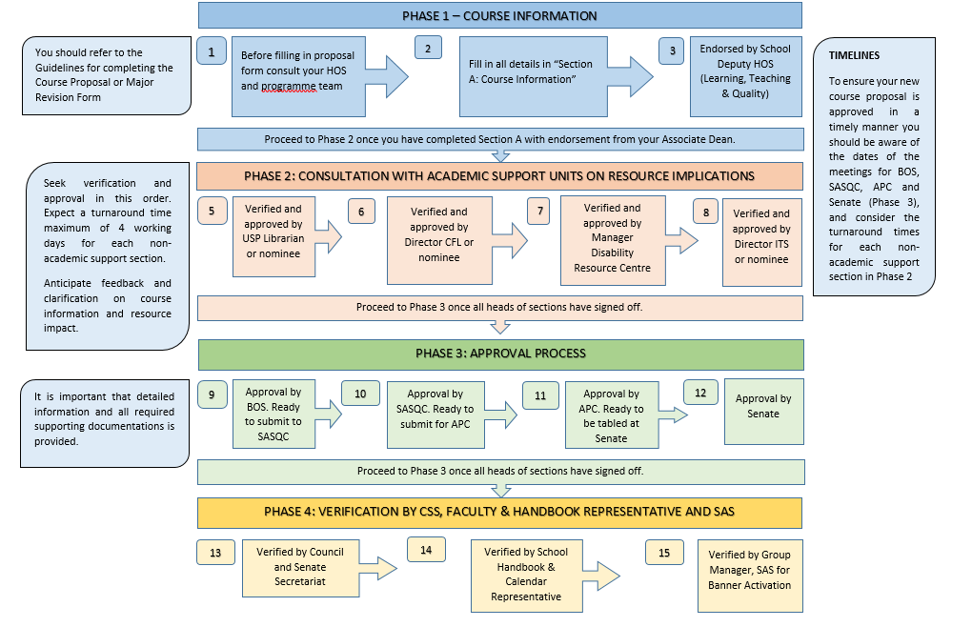
Section A: Course Information

Course Profile
The course profile has been set out in a manner that should facilitate entries into the USP Handbook and Calendar.

Responsible Staff
This staff member may or may not be the course coordinator, but is the person responsible for completing the proposal form at that point in time.

Expected number of students by mode for next 3 years
In the case of a new course, the number of students is an approximate of market analysis and an estimate based on existing number of students at the same level in the programme. The latter can be obtained from DIBS.

Course Rationale
The course rationale needs to set out a well-supported case for the proposal and should:
- Explain the need for the proposal of a new course or making substantial changes to an existing course.
- Describe where the course fits into the overall programme/major and how it helps to build and progress the core content knowledge and competencies expected from graduates in the programme.

Note: Please ensure that you fill in the appropriate section for either an Undergraduate or a Postgraduate course.

Research Skills Development (RSD)
Please consult with the RSD Coordinator to verify whether the proposed course will need to have an explicit RSD component.

Assessment Portfolio and Alignment
The purpose of this section is to indicate exactly how the choice of assessment task is appropriate for a particular CLO. Assessment tasks cannot be aligned to a particular CLO if the assessment task is not assessing the CLO precisely. Additionally, an assessment task that assesses the development of functional knowledge and practical skills cannot be aligned with a CLO that requires the demonstration of declarative knowledge.
For example, if the CLO states that students need to explain an idea or concept, then the assessment task should not be requiring students to solve a problem or do a laboratory experiment. Conversely, if the CLO states that students need to apply particular knowledge, the assessment task cannot be a written test that simply requires students to write short descriptive answers.
Use the comments/rationale column to highlight the exact relationship between a specific CLO and the associated assessment task.
For example, instead of just saying something like: the test assesses topics 1-4, say something like: the test includes describing, application and problem-solving questions.
Student Workload
It should be noted that the learning hours per semester for an undergraduate and a postgraduate course are between 187-225 hours and 375-450 hours, respectively.

Student workload should be calculated realistically and incorporate recognition of both preparation and consolidation time.

Learning Resources
It is strongly recommended that the proposed course have appropriate inclusion of Open Educational Resources (OER). Refer to the USP OER Policy.
Learning Outcomes and Alignment for Undergraduate Courses

Course Learning Outcomes (CLO)
In order to complete this section, the course learning outcomes (CLO) need to be developed/refined in relation to the Programme Graduate Outcomes (PGO) and USP Graduate Outcomes.

Course learning outcomes are not simply a restatement of course content and do not need to provide all the details of the content. For further information on writing effective course learning outcomes, refer to Writing Learning Outcomes: Beyond a Compliance Exercise on the DVC Education website.

Programme Graduate Outcomes (PGO)
Programme Graduate Outcomes (PGO) articulate the discipline goals for a particular programme/major. These are the discipline content, competencies, skills, values, dispositions and behaviours that graduates of a programme will be expected to demonstrate at or near the completion of their programme/major.

Proposing a new course or revising an existing course is an opportune time to review PGO as a discipline team, to ensure that they are current and genuinely reflect the direction and goals of a programme/major. If this is done accurately, the alignment of the PGO with the proposed course learning outcomes will be pedagogically a valuable and authentic exercise.

The full list of PGO as at January 2018 is available on the DVC Education website. For programmes that have revised their PGO and associated rubrics since January 2018 in consultation with the DVC Education Office, these changes have also been updated on this website.

Note: Heads of Schools/Centres/Institutes need to liaise with the DVC Education Office to ensure that the most recent version of the PGO is available on the DVC Education website.

Alignment of Course Learning Outcomes (CLO) and Programme Graduate Outcomes (PGO)
This alignment needs to be carried out with reference to PGO and associated rubrics, as well as the curriculum map for the programme in which this course is a core offering. The staff member responsible for proposing/revising the course needs to liaise with the Head of School or visit the DVC Education website to access the most recent version of the PGO, associated rubrics and the curriculum map for the alignment exercise.

There needs to be a clear correspondence between the level at which a CLO is written and the expectation/level of performance indicated in the PGO rubrics. A CLO can only be said to be aligned with a particular PGO if the verb of the CLO corresponds to the verb/descriptor of the PGO.

For example, a CLO that uses verbs such as describe or explain cannot be aligned to a PGO of problem solving or evaluation. The reason for this is because the terms describe or explain do not include the expectation for problem solving or evaluation.

It is important to do the alignment accurately otherwise, this exercise is rendered meaningless.

Alignment of Course Learning Outcomes (CLO) and USP Graduate Outcomes
This alignment needs to be carried out with reference to USP Graduate Outcomes and associated rubrics as well as the curriculum map for the programme in which this course is a core offering. The most recent version of USP Graduate Outcomes and associated rubrics (approved in Senate 2 of 2017) can be obtained from the DVC Education website.

Alignment with USP Graduate Outcomes should follow the steps outlined in the notes for alignment to PGO.

Learning Outcomes and Alignment for Postgraduate Courses

Course Learning Outcomes (CLO)
In order to complete this section, the CLO need to be developed/refined in relation to the PGO for postgraduate programmes and the new USP Postgraduate Outcomes. The postgraduate CLO need to be at a more advanced level than those of the undergraduate programmes and need to reflect the higher order thinking that is indicative of a postgraduate level course (diploma, masters and doctoral).

Programme Graduate Outcomes (PGO)
At the postgraduate level, the PGO will describe the discipline goals for a specific postgraduate diploma, masters or doctoral programme. All postgraduate programmes need to articulate a set of PGO as it is impossible to complete the alignment and mapping exercise for a new/revised course without having the PGO in place.

Alignment of Course Learning Outcomes (CLO) and Programme Graduate Outcomes (PGO)
This alignment needs to be carried out with reference to postgraduate PGO at the pertinent level (diploma, masters and doctoral) as well as a curriculum map for the programme.

Alignment of Course Learning Outcomes (CLO) and USP Postgraduate Outcomes
This alignment needs to be carried out with reference to USP Postgraduate Outcomes as well as the curriculum map for the programme at the pertinent level. The new USP Postgraduate Outcomes for diploma, masters and doctoral levels (approved in Senate 3 of 2018) can be obtained from the DVC Education website.

