BA Communication & Media Programme Planner

Name: |  | Student ID:

Fill in your specialist subject choices in the table below. Plan which semester you will take each course. See p.2 for examples and the guidance on www.usp.ac.fj/communication-media. Email a copy to fiona.willans@usp.ac.fj for approval before registering for courses.
APPROVAL Signed:

Date:
Year 1 core courses: | Semester 1 | Semester 2
UU114 English Language Skills for Tertiary Studies (Both semesters)
UU100 Communications & Information Literacy (Both semesters)
JN101 Introduction to Journalism (Semester 1) | JN101
JN103 Media Law & Ethics (Semester 2) |  | JN103
LN111 Introduction to Language Studies (Semester 1) | LN111
MG101 Introduction to Management (Both semesters)
Year 1 specialist subject (take 2 courses at 100-level): | Semester 1 | Semester 2
1.
2.
Year 2 core courses: | Semester 1 | Semester 2
UU200 Ethics & Governance (Both semesters)
UU204 Pacific Worlds (Both semesters)
JN201 Print & Online Journalism (Semester 1) | JN201
LN216 Language Use in the 21st Century Pacific (Semester 2) |  | LN216
MG206 Marketing Principles & Strategies (Semester 1) | MG206
Take 1 or 2 of the following courses: | Semester 1 | Semester 2
JN202 Radio Broadcasting (Semester 1)
JN203 Television Journalism (Semester 2)
LN211 Structure of English (Semester 1)
Year 2 specialist subject (take 1 or 2 courses at 200-level): | Semester 1 | Semester 2
1.
(2.)
Year 3 core courses: | Semester 1 | Semester 2
JN303 Journalism Production (Semester 2) |  | JN303
LN317 Qualitative Analysis of Texts (Semester 1) | LN317
MG303 International Marketing (Semester 2) |  | MG303
Take 3 or 4 of the following courses: | Semester 1 | Semester 2
JN301 International Journalism (Semester 1)
JN302 Journalism Research (Semester 2)
LN311 English in the Pacific (Semester 2)
LN315 Corpus Linguistics & Language Technologies (Semester 1)
MG301 Management of Service Operations (Semester 1)
Year 3 specialist subject (take 1 or 2 courses at 300-level): | Semester 1 | Semester 2
1.
(2.)

Example 1 (Specialist subject: French with Linguistics)
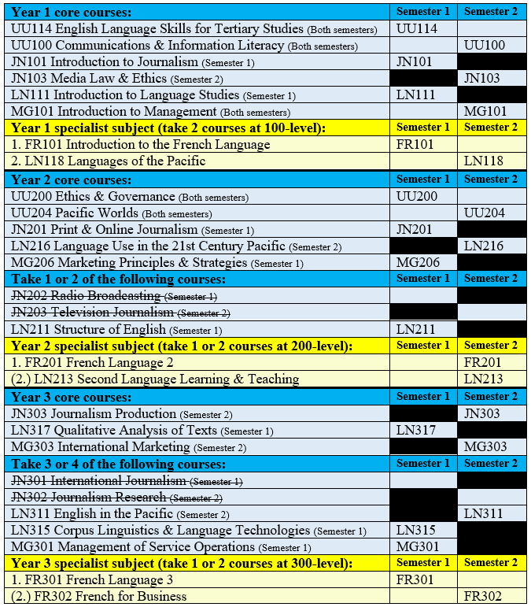
Example 2 (Specialist subject: Economics)
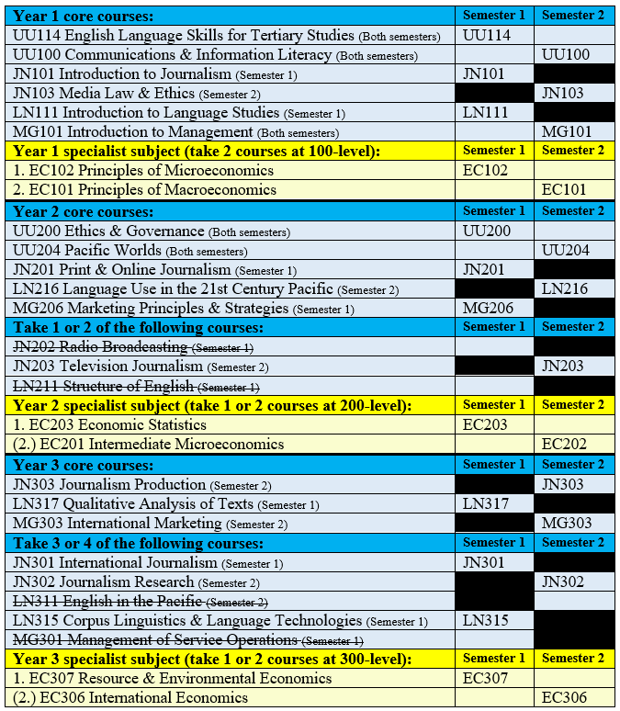

These are just examples! You can choose any specialist subject you like as long as you meet all the pre-requisite requirements. Note: The semester offerings shown in the examples were correct as of 2024. Always check the latest handbook and calendar at www.usp.ac.fj/publications in case of changes.

